**May 2,2025**

**CC-215 DATABASE SYSTEM**

FAIQA LATIF (110790) TOOBA FATIMA (110789)

**Instructor: Miss Sehrish khan**

Database Design and Implementation in MySQL

* Entity Relationship Diagram
* Relational schema\table schema
* Normalization
* Implementation in MySQL

**Problem Statement**

**Grocery Delivery App with Vendor Reviews and Weekly Subscriptions**

A grocery delivery system enables users to either place instant grocery orders or subscribe to curated weekly bundles (like "Healthy Heart Kit"). Products come from multiple verified vendors. The system tracks vendor reliability and quality through customer ratings. Users can customize subscriptions, postpone deliveries, or swap out items. The inventory system predicts restocking needs and manages perishable item expiration alerts.

**ENTITY RELATIONSHIP DIAGRAM**

ERD stands for Entity-Relationship Diagram. It's a visual representation of the structure of a database, showing the relationships between entities (tables) and their attributes.

Entity relationship diagram is of 2 type:

* Crow Feet Model
* Chen Model

**ENTITY RELATIONSHIP DIAGRAM USING CHEN MODEL**

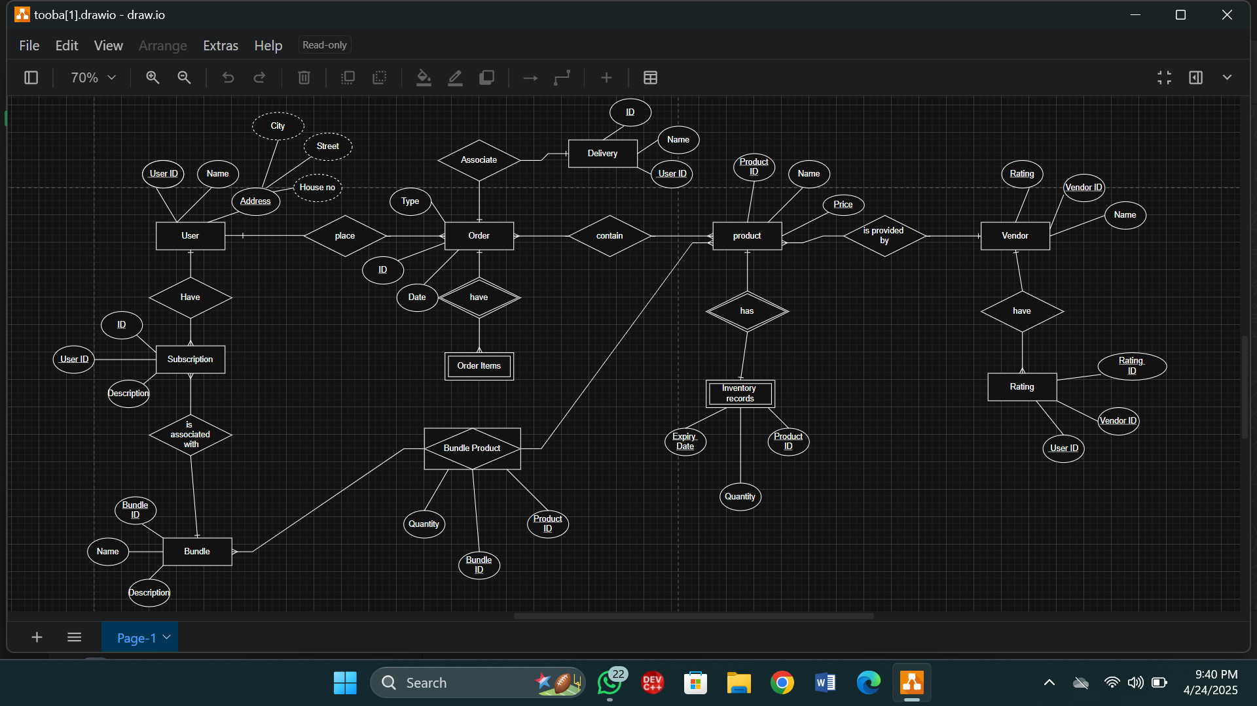

**CROW FOOT MODEL:**

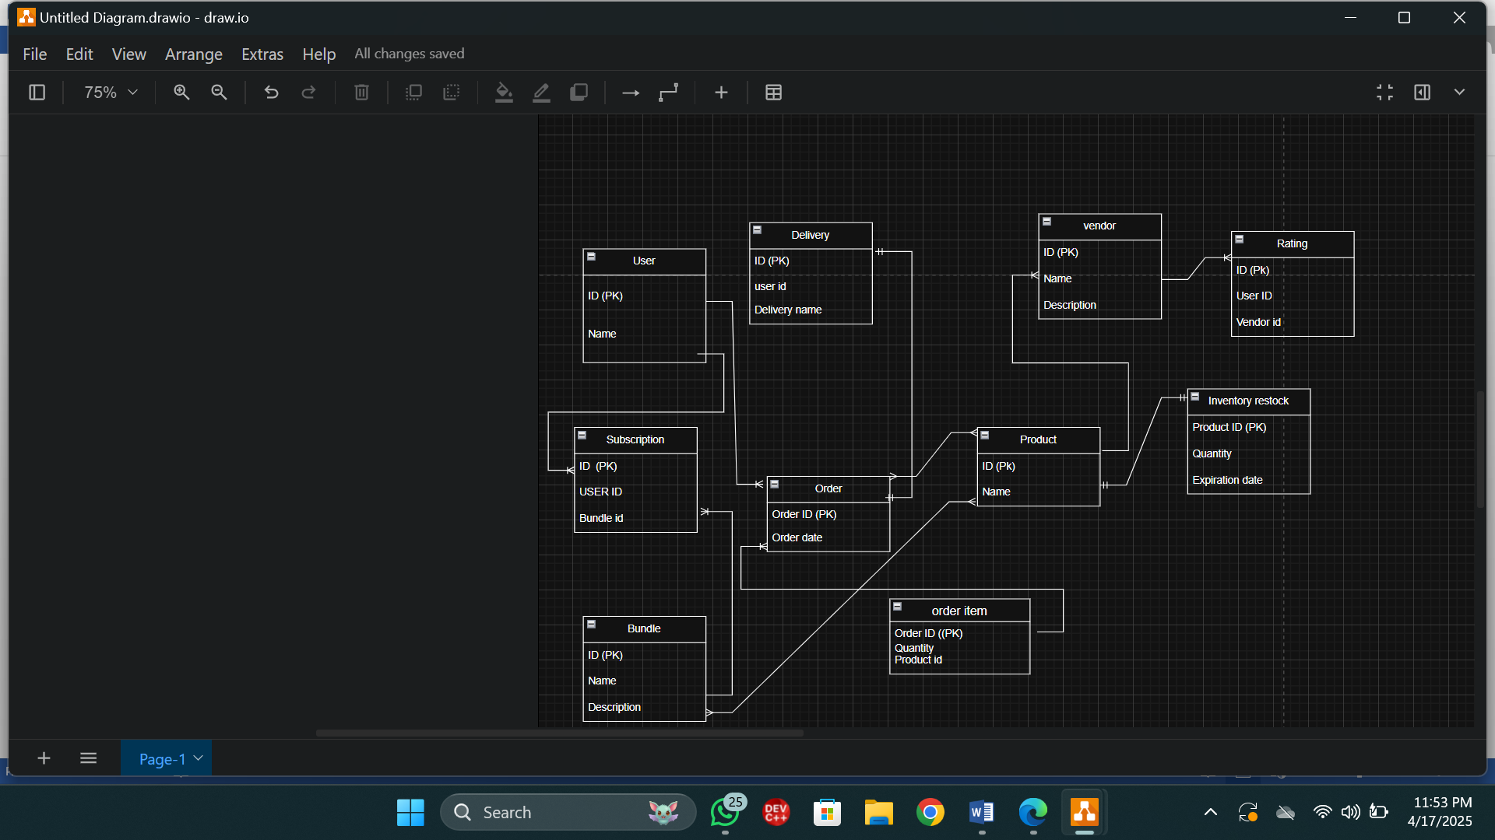

**Relational schema\table schema**

**User** ( User_ID (PK), Name, Email, Address)

**Vendor(** Vendor_ID (PK), Name, Rating)

**Product (** Product_ID (PK), Name, Price, Vendor_ID (FK), Category)

**Order** (Order_ID (PK), User_ID (FK), Order_Date, Total_Cost, Status)

**Order_item** ( Order_ID (FK), Product_ID (FK), Quantity)

**Bundle**  (Bundle_ID (PK), Name, Description)

**Subscription** (Subscription_ID (PK), User_ID (FK), Bundle_ID (FK), Frequency, Status)

**Product_Bundle** (Bundle_ID (FK), Product_ID (FK), Quantity)

**Inventory** (Product_ID (FK), Quantity, Expiration_Date, Restock_Threshold)

**Delivery** (Delivery_ID (PK), Order_ID (FK), Delivery_Date, Status)

**Rating** (Rating_ID (PK), User_ID (FK), Vendor_ID (FK), Rating, Review)

**NORMALIZATION**

Normalization is a process of organizing data in a database to minimize redundancy and improve data integrity.

The **main objective** of database normalization is to eliminate redundant data, minimize data modification errors, and simplify the query process.

* **Every table has primary key.**
* **Other keys depend upon primary key.**
* **Field must contain atomic values.**

**FIRST NORMAL FORM (1NF):**

Each table cell contains a single value. No repeating groups or arrays in a single column. 1NF eliminates data redundancy and improves data integrity by organizing data into well-structured tables. In 1NF there must be a primary key.

Each attribute contains only atomic (indivisible) values, and there are no repeating groups of columns.

**SECOND NORMAL FORM (2NF):**

Second Normal Form (2NF) is a level of database normalization that builds on First Normal Form (1NF). A table is in 2NF if:

There is no partial dependency of any column on a composite primary key.

All non-key attributes depend on the entire primary key.

All non-key attributes are fully functionally dependent on the entire primary key in above schema.

**THIRD NORMAL FORM (3NF):**

Third Normal Form (3NF) in database normalization eliminates transitive dependencies, ensuring that each non-key attribute in a table depends only on the primary key, not on other non-key attributes. It builds upon First Normal Form (1NF) and Second Normal Form (2NF).

3NF eliminates indirect dependencies, ensuring that each non-key attribute depends directly on the primary key.

**COMMON COMMANDS:**

**1. To see existing databases:**

**show databases**;

**2. To Create a database:**

**CREATE DATABASE database_name;**

**3. To use the database:**

**use database_name;**

**4. To see existing TABLES:**

**show tables;**

**5. To Create a tables:**

**create table table_name(attribute_id_1 type(domain) primary key, attribute_2 type(domain),…,n);**

**6. To describe table:**

**describe table_name;**

**7. To see values from table:**

**select * from table_name;**

**8. To add foreign key in existing table:**

**alter table table_name ADD constraint fk_table_name foreign key (attribute) references ref_table(ref_attribute);**

**IMPLEMENTATION IN MYSQL**

* **show databases;**
* **create database grocerysys;**

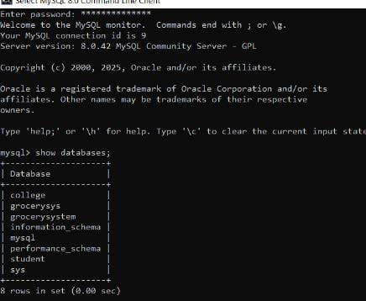

* use grocerysys;
* show tables;

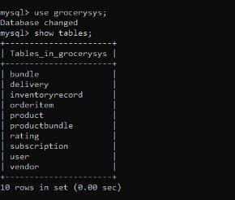

* create table user(user_id INT(3) PRIMARY KEY,user_name varchar (15),user_address varchar(23) NOT NULL);
* DESCRIBE user;
* create table vendor(vend_id INT(4) PRIMARY KEY,vend_name varchar (18) NOT NULL);
* DESCRIBE vendor;
* Create table bundle(bun_id INT (5) PRIMARY KEY,bun_name varchar(16),bun_description varchar(17) NOT NULL);
* DESCRIBE bundle;
* Create table delivery(del_id INT(5) PRIMARY KEY,del_namevarchar(16),user_id INT(7) NOT NULL);
* DESCRIBE delivery;

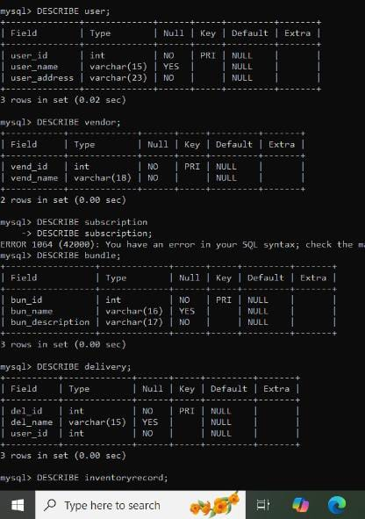

* Create table inventoryrecord(prod_id INT(5) PRIMARY KEY,inv_quantity INT(19),inv_expirydate INT(6) NOT NULL);
* DESCRIBE inventoryrecord;

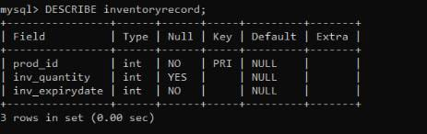

* Create table orderd(order_id INT(7) PRIMARY KEY,order_date DATE NOT NULL,order_type varchar(255) NOT NULL);
* DESCRIBE ordered;

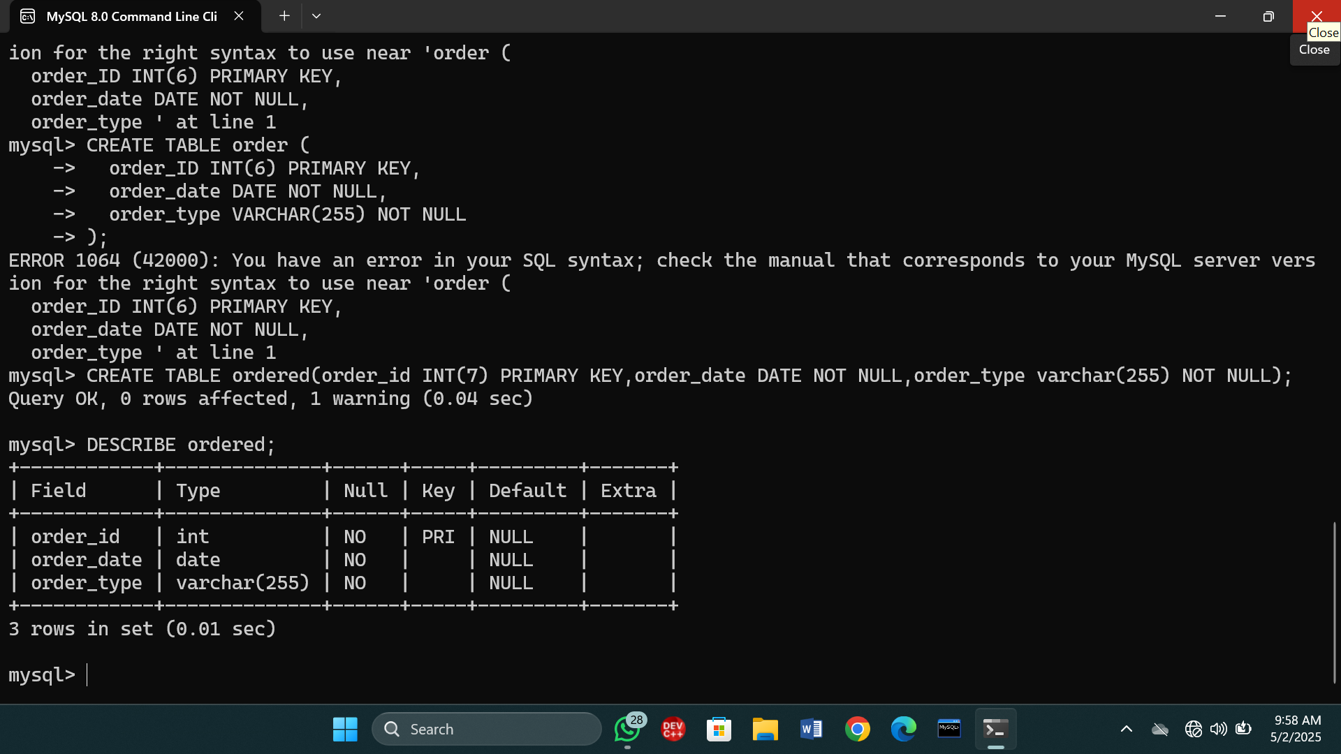

* create table orderitem(ord_id INT(5) PRIMARY KEY,prod_id INT(7),orderit_quantity INT(7) NOT NULL);
* DESCRIBE orderitem;
* Create table product(prod_id INT(6) PRIMARY KEY,prod_name varchar(15),prod_price INT(4) NOT NULL);
* DESCRIBE product;

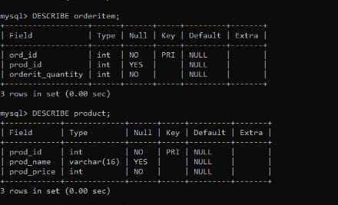

* Create table productbundle(prod_id INT(6) PRIMARY KEY,bun_id INT(7),productbun_quantity(7) NOT NULL);
* DESCRIBE productbundle;
* Create table rating(rat_id INT(8) PRIMARY KEY,vend_id INT(7),user_id INT(5) NOT NULL);
* DESCRIBE rating;
* Create table subscription(sub_id INT(7) PRIMARY KEY,user_id INT(5),sub_description varchar(25)NOT NULL);
* DESCRIBE subscription;

